Pro-face America GP-Pro EX

Software Download Walk-though Guide

Pro-face America Website: <https://www.proface.com/en>

Click on the **Products** drop down menu, then click **Software**.

Select the **GP-Pro EX** option.

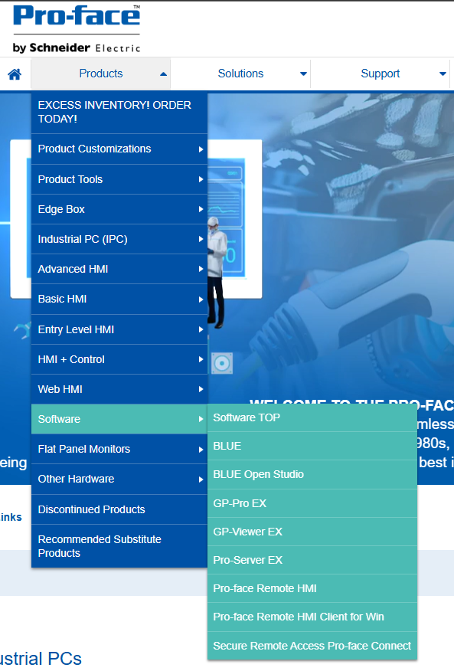

This will take you to the main product page for GP-Pro EX.

Select the **Support / Downloads** option.

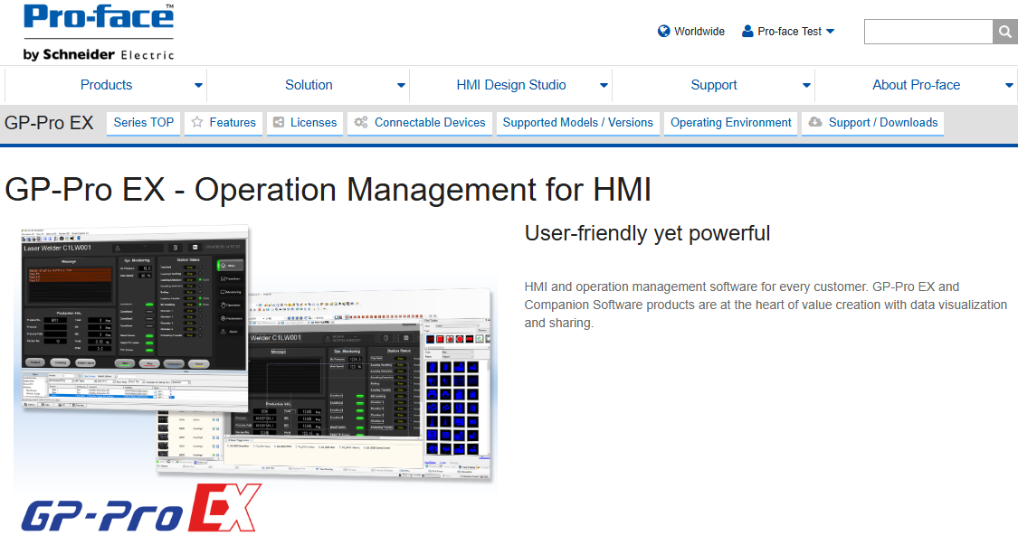

The **GP-Pro EX Support / Downloads** page will be shown.

Select the **GP-Pro EX Trail Version** – Under the **Update Modules** section.

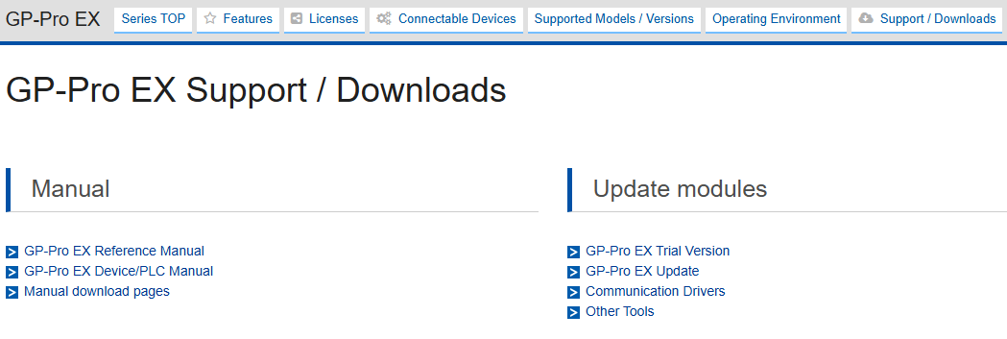

GP-Pro EX Trail Version Download Request

Enter in your information to register for the software download.

Once complete, select the **Go to Download Page**

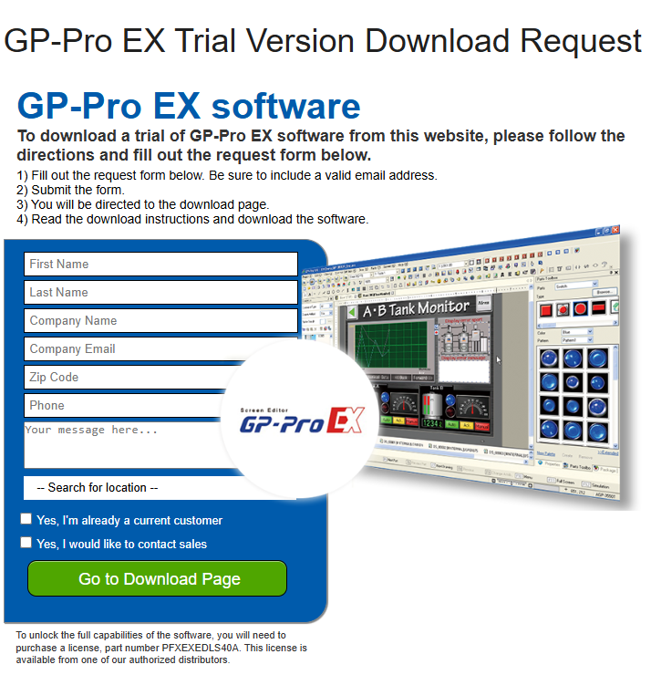

**GP-Pro EX V4.09.600 Limited Edition Download** page.

Click on the **Download** button.

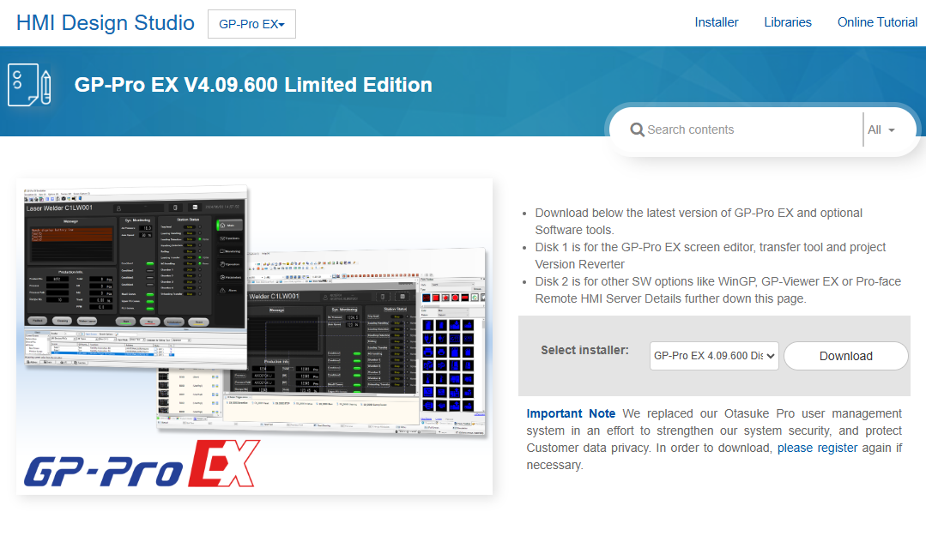

You will now need to either sign in with your **Pro-face by Schneider Electric** account, or you will need to create a new account by going to the **Register Here** option.

* **Proceed to Next Step if you do not already have an account.**

If you have a **Pro-face by Schneider Electric** account, log into the account.

This will take you back to the **GP-Pro EX V4.09.600 Limited Edition Download** page.

You will now be able to select the **Download** option to start the download of GP-Pro EX

The **Select Installer** gives you the option to download Disk 1 and Disk 2 of the software.

* 1. Disk 1 – GP-Pro EX screen editor, transfer tool and project Version Reverter
  2. Disk 2 – Other SW options like WinGP, GP-Viewer EX or Pro-face Remote HMI Server



Create your **Pro-face by Schneider Electric** account.

Enter **Email address** or **Mobile phone number**.

Select **Continue** and complete the required information.

Then, select **Register** to complete the account creation.

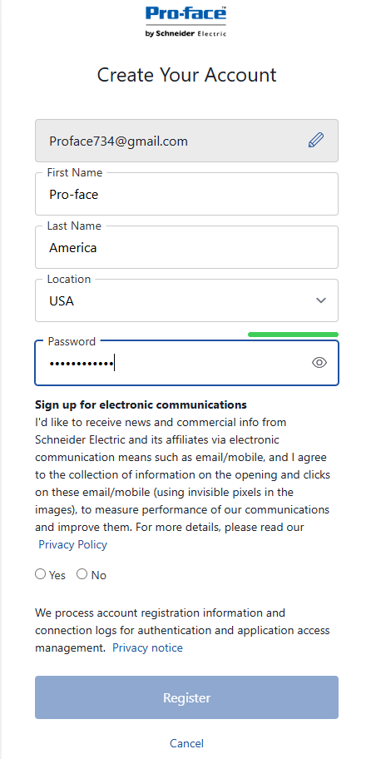

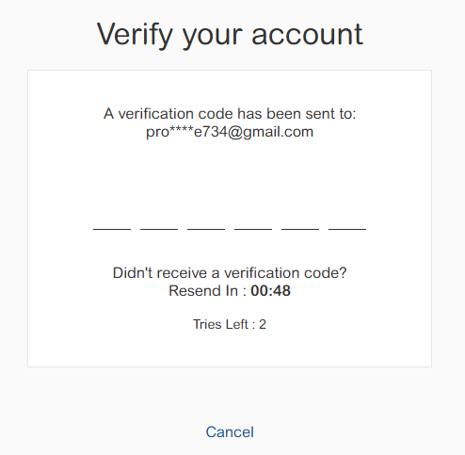

You will now need to Verify your account.

After account verification, you will be redirected back to the **GP-Pro EX V4.09.600 Limited Edition Download** page.

You will now be able to select the **Download** option to start the download of GP-Pro EX

The **Select Installer** gives you the option to download Disk 1 and Disk 2 of the software.

1. Disk 1 – GP-Pro EX screen editor, transfer tool and project Version Reverter
2. Disk 2 – Other SW options like WinGP, GP-Viewer EX or Pro-face Remote HMI Server

