Pro-face America GP-Pro EX
Software Download Walk-through Guide

Pro-face America Website: https://www.proface.com/en

Click on the Products drop down menu, then click Software.
Select the GP-Pro EX option.
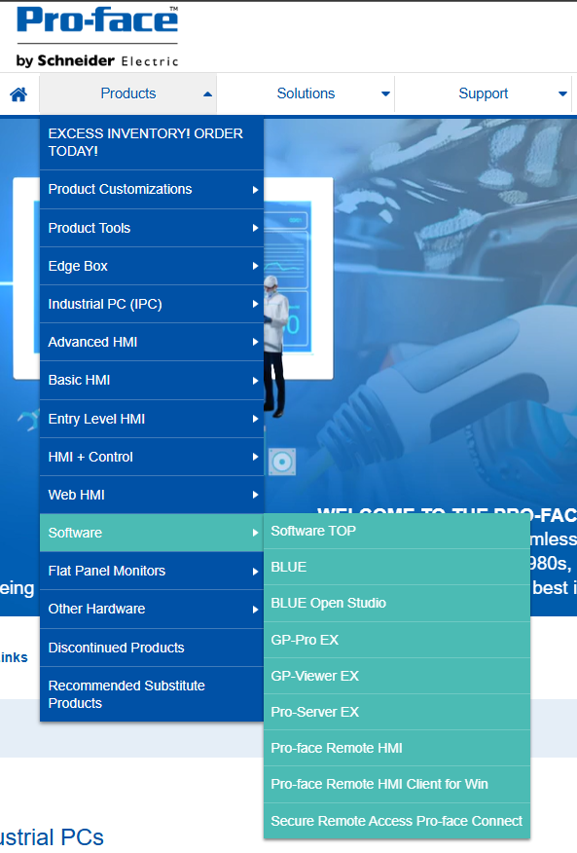

This will take you to the main product page for GP-Pro EX.
Select the Support / Downloads option.
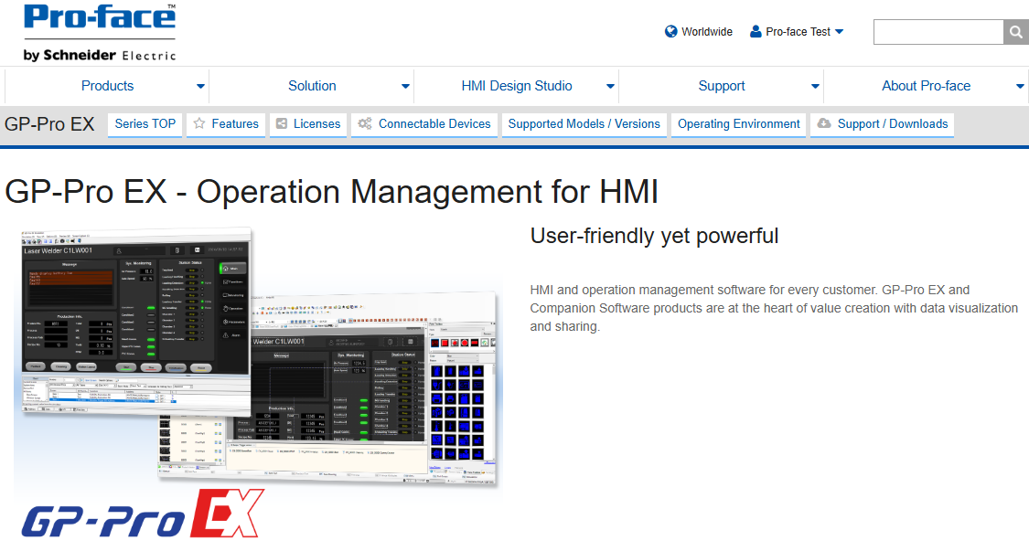

The GP-Pro EX Support / Downloads page will load.
Select the GP-Pro EX Trail Version – Under the Update Modules section.
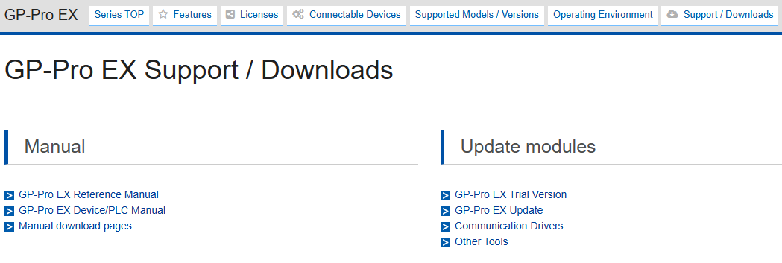

GP-Pro EX Trail Version Download Request
Enter in your information to register for the software download.
Once complete, select the Go to Download Page
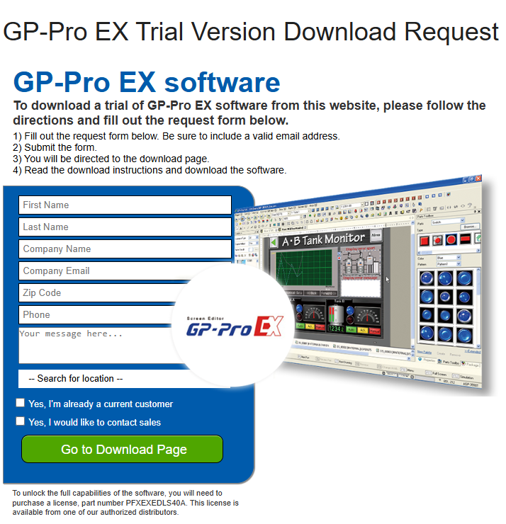

GP-Pro EX V4.09.600 Limited Edition Download page.
Click on the Download button.
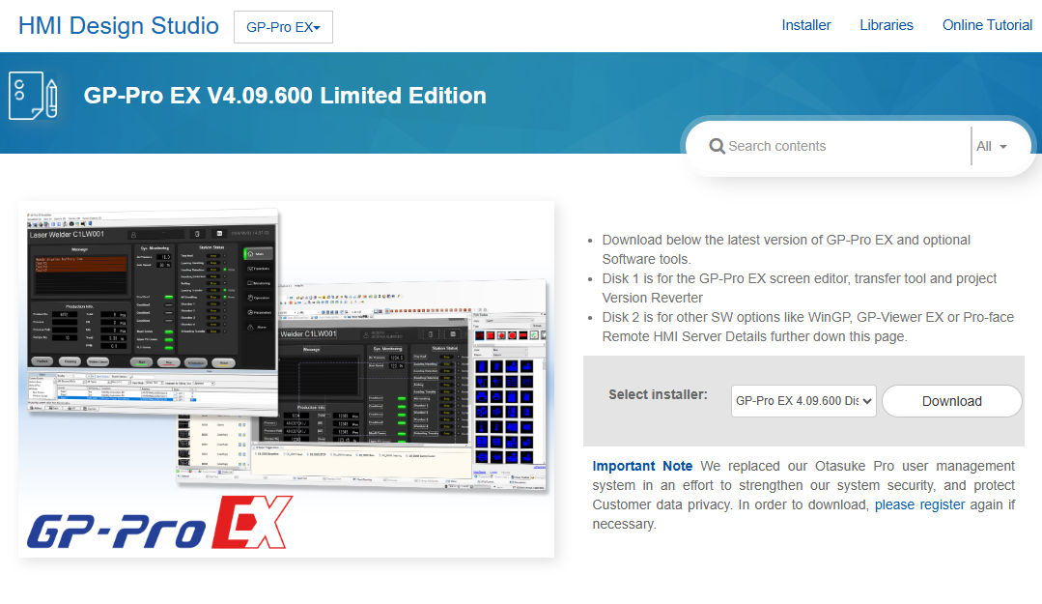

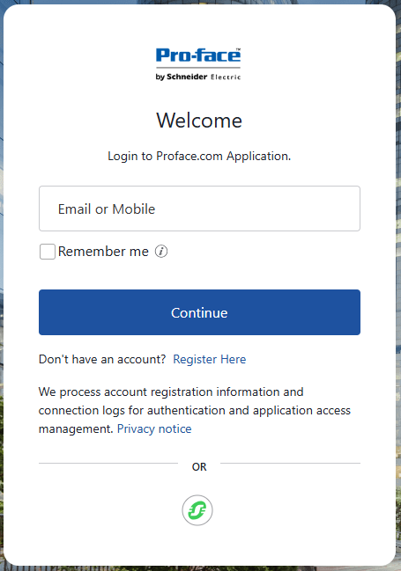
You will now need to either sign in with your Pro-face by Schneider Electric account, or you will need to create a new account by going to the Register Here option.

- Proceed to Next Step if you do not already have an account.
If you have a Pro-face by Schneider Electric account, log into the account.
This will take you back to the GP-Pro EX V4.09.600 Limited Edition download page.
You will now be able to select the Download option to start the download of GP-Pro EX
The Select Installer gives you the option to download Disk 1 and Disk 2 of the software.
  - Disk 1 – GP-Pro EX screen editor, transfer tool and project Version Reverter
  - Disk 2 – Other SW options like WinGP, GP-Viewer EX or Pro-face Remote HMI Server

Create your Pro-face by Schneider Electric account.
Enter Email address or Mobile phone number.
Select Continue and complete the required information.
Then, select Register to complete the account creation.
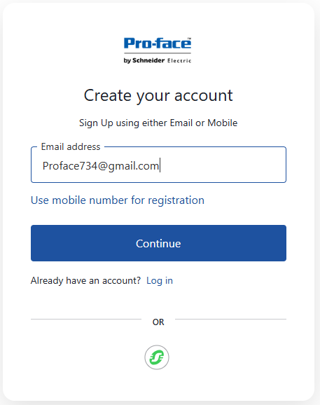
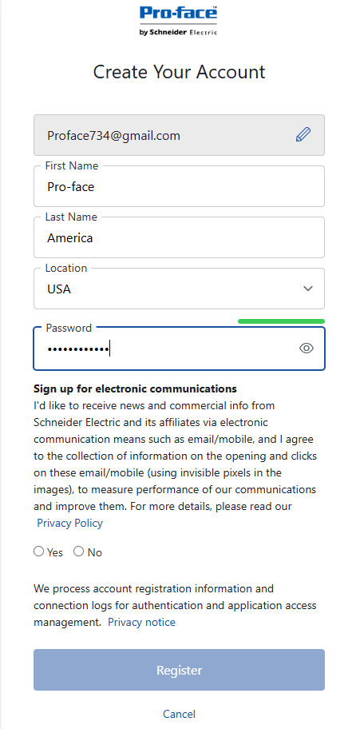

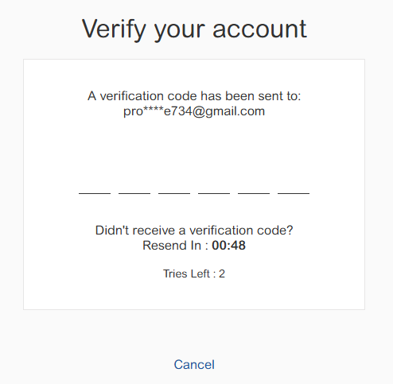
You will now need to Verify your account.

After account verification, you will be directed back to the GP-Pro EX V4.09.600 Limited Edition download page.
You will now be able to select the Download option to start the download of GP-Pro EX
The Select Installer gives you the option to download Disk 1 and Disk 2 of the software.
- Disk 1 – GP-Pro EX screen editor, transfer tool and project Version Reverter
- Disk 2 – Other SW options like WinGP, GP-Viewer EX or Pro-face Remote HMI Server

